**Fancy the Motorhome Lifestyle? What can I drive on my licence?**

[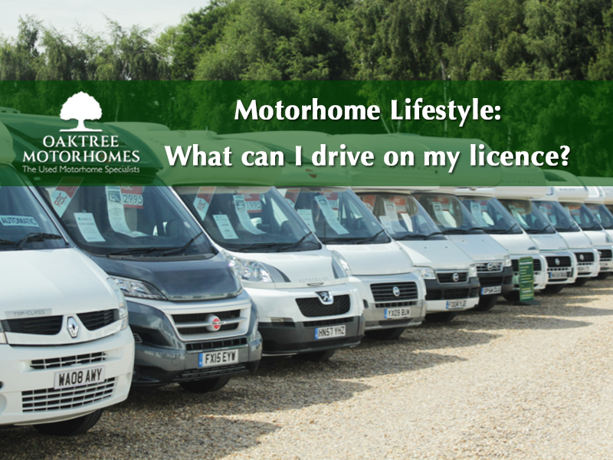](https://www.omcmotorhomes.co.uk/used/motorhomes)

**WHAT DRIVING LICENCE DO I NEED FOR A CAMPERVAN OR MOTORHOME?​**

With motorhome ownership becoming more attractive for us Brits (after all, we’re world renowned explorers, aren’t we?) you may find it useful to know what types of vehicles you can drive on your licence.

The UK driving licence terms can sometimes be difficult to understand, but in this article, we’d like to straighten things out as it’s not as complex as it might seem.

It's basically down to 2 things -**weight** (the vehicle, not you) and **age**(you, not the vehicle) ...

**So, When did you pass your test?​**

Firstly, the key to all of this is the date you passed your driving test. **Was it before or after 1st January 1997?** To drive certain types of vehicles, you’ll need an ‘entitlement’ for that category on your driving licence. and that date signifies the transition between the different entitlements you received.

If you can gather together the following information, then you can use the [**GOV.UK**](https://www.gov.uk/view-driving-licence) web site to give you loads of useful licence and vehicle category information.

**You’ll need 3 things:**

1. Your Driving Licence Number
2. Your National Insurance Number. If you don't know it then click the following link to find a lost NI No. [Find a lost NI number](https://www.gov.uk/lost-national-insurance-number)
3. The postcode on your driving licence

When you’ve got that information together then click on the following link [**check online to see what vehicles you can drive**](https://www.gov.uk/view-driving-licence) and then follow the process by clicking on the big green button labelled **START NOW**.

There will be 4 tabs of information displayed.  The second tab will list all the **‘Vehicles you can drive’**.

Here’s what the page should look something like.

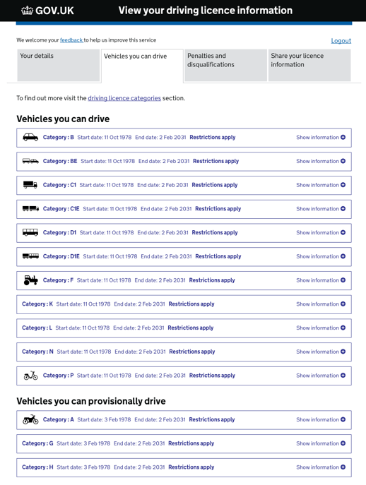

If your results are different to those above, then you may find that it’s due to an age restriction and a change in the rules.  Let us explain…

**DID YOU PASS BEFORE 1 JANUARY 1997?**

If you passed your Driving test before 1 January 1997 you will automatically have category C1 entitlement on your licence as you can see below.

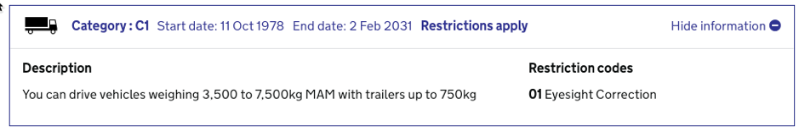

As you can see in the table above, this will allow you to drive vehicles with a Maximum Authorised Mass (MAM) up to 7,500kg.  As you will also automatically get C1E you can tow a trailer of up to 750kg - see below.

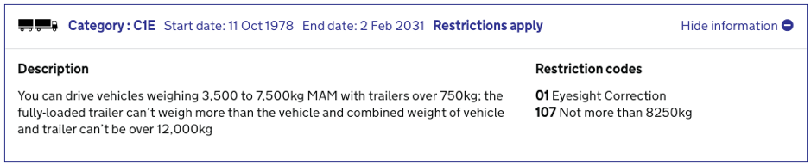

This limit will enable you to drive all but the largest American-RV-style motorhomes, but we’ll deal with those special cases further down this post.

Your driving licence will show the categories you are entitled to drive. If you have the older-style paper licence they are clearly listed on the front of your licence. On newer two-part licences, they are given on the back of the pink photo card. Like this:

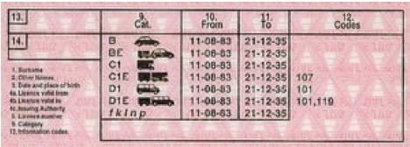Pink Card Driving License before 1-1-1997

**DID YOU PASS AFTER 1ST JANUARY 1997**

The standard driving licence issued to a driver passing his or her test today (after 1 January 1997 of course) covers categories B and B1. This means you can drive a vehicle with a MAM of up to 3,500kg (B) and tow a trailer up to 750kg behind it. Your licence may well look more like this figure below. Many new motorhomes are built with a MAM of less than 3,500kg so that almost anyone with a full licence can drive them.

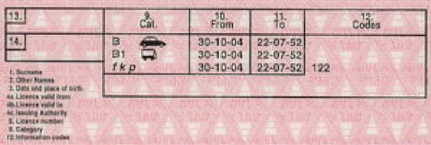Pink Card Driving License after 1-1-1997

**Driving a larger motorhome over 3500kg​**

If you want to drive a larger motorhome (over 3500kg), you will need to pass an additional driving test to add the C category to your licence. In the commercial world this is an entry-level HGV licence and is referred to as either Rigid Body, Class 2 or an LGV, but you cannot add a trailer (or tow a car) unless you pass a further test for the upgraded CE license

**Driving a really large American RV-style motorhome ​**

If you want to drive a really large motorhome like an American RV (and possibly tow a car too) then you may need to have passed both the C and CE tests to gain those categories and is referred to as a Class 1 Heavy Goods Vehicle (HGV) licence.

Further Information on driving licence categories can be found - [**www.gov.uk/driving-licence-categories**](http://www.gov.uk/driving-licence-categories)

**LICENCE REQUIREMENTS IN A NUTSHELL…**

**A Date to remember**

Your licence entitlement depends on when you passed your driving test and the key date to remember is **1st January 1997 (01/01/1997).**  Your available categories are more limited if you passed ON or AFTER this date.

**Maximum Authorised Mass**

Maximum authorised mass (MAM) means the total weight of a vehicle or trailer INCLUDING the maximum load that can be carried safely when it’s being used on the road.

This is also known as **gross vehicle weight** (GVW) or **permissible maximum weight**.

It will be listed in the owner’s manual and is normally shown on a plate or sticker fitted to the vehicle.

The plate or sticker may also show a **gross train weight**(GTW), also sometimes called **gross combination weight** (GCW). This is the total weight of the tractor unit plus trailer plus load.

**GOV.UK**

Here is a link to the GOV.UK website that explains vehicle weights more concisely. [**Vehicle Weights Explained - GOV.UK**](https://www.gov.uk/vehicle-weights-explained) but I've included it here in summary.

**Driving Licence Categories**

Click here to view the GOV.UK web page regarding [**Driving Licence Categories**](https://www.gov.uk/driving-licence-categories).  It explains in detail all the categories outlined below.  We’ve left off all the non-motorhome related ones for clarity.

**SMALLER MOTORHOMES AND CAMPERVANS**

**Category B**

To drive the smaller motorhomes and campervans weighing less than 3,500kg, your car driving licence (category B) will usually be sufficient. There is a date dependent (01/01/1997) change in the category that allows drivers who passed before that date to drive any vehicle and trailer combination up to 8,250kg MAM.

**MEDIUM-SIZED VEHICLES**

**Category C1**

You can drive vehicles between 3,500 and 7,500kg **[MaM](https://www.gov.uk/vehicle-weights-explained)** (with a trailer up to 750kg).

**Category C1E**

You can drive C1 category vehicles with a trailer over 750kg, but the trailer - when fully loaded - can’t weigh more than the vehicle.

The combined [**MAM**](https://www.gov.uk/vehicle-weights-explained) of both can’t exceed 12,000kg.

**LARGE VEHICLES**

**Category C**

You can drive vehicles over 3,500kg (with a trailer up to 750kg [**MAM**](https://www.gov.uk/vehicle-weights-explained)).

**Category CE**

You can drive category C vehicles with a trailer over 750kg.

* Duplicate Section
* Add Section
* Save Section
* Remove Section
* Duplicate Column
* Add Column
* Remove Column
* Duplicate Widget
* Save Widget
* Remove Widget

The information in this article was correct as of 9 Jan 2018. The information provided here is for your guidance only and does not constitute legal advice. If in doubt please do your own research.